# **Software Requirements Specification (SRS)**

## **Learning Management System with Personalized Recommendations**

## **Team:**

### Vishak Kashyap K

### Shreyas Deb

### Sanyam Agrawal

### Arshiya Noureen

### Kushal Mangla

## **1. Brief Problem Statement**

The project aims to develop a Learning Management System (LMS) that provides personalized learning experiences through AI-powered recommendations. The system will enable users to access various self-learning materials including videos, blogs, and resources, with content suggestions tailored to their skill level and interests, similar to Netflix's recommendation system. The platform will serve multiple user roles including learners, coaches, and administrators, each with specific functionalities and access levels.

## **2. System Requirements**

### **2.1 Technical Requirements**

* Frontend: React.js with TypeScript, Tailwind CSS/Ant Design
* Backend: Node.js with Express.js
* Database: NoSQL
* Recommendation Engine: Python with ML libraries (scikit-learn, pandas, numpy)
* Authentication: Firebase Auth or JWT
* APIs: REST APIs for communication
* Hosting: Two VM nodes
  + Node 1: Frontend and Moodle
  + Node 2: Backend and Recommendation Engine
* Integration Requirements: Moodle LMS, YouTube API

### **2.2 Hardware Requirements**

* Server Requirements:
  + Two separate VM nodes for hosting different components
  + Sufficient storage for learning materials and user data
  + Adequate RAM and processing power for ML operations
* Client Requirements:
  + Modern web browser
  + Internet connection
  + No specific hardware requirements for end-users

## **3. User Profile**

### **3.1 Learners**

* Primary users of the system
* Varying levels of technical expertise (beginner to advanced)
* Comfortable with basic web navigation
* Interested in self-paced learning
* May access the system from various devices

### **3.2 Coaches**

* Subject matter experts
* Familiar with content management systems
* Responsible for content creation and learner monitoring
* Regular users of the system

### **3.3 Administrators**

* Technical users with system management responsibilities
* Familiar with LMS administration
* Regular users with full system access

## 

## **4. Feature Requirements**

| **No** | **Use Case Name** | **Overview** | **Release** |
| --- | --- | --- | --- |
| 1 | Registration and Login | Allows new users to create accounts and existing users to access the system securely | R1 |
| 2 | Manage Profile | Enables users to update their personal information and preferences | R1 |
| 3 | View Personalized Profile | Displays user-specific information and personalized recommendations | R2 |
| 4 | Search and Filter Content | Allows users to find specific learning materials using search criteria | R1 |
| 5 | Access Learning Materials | Provides access to learning resources | R1 |
| 6 | Track Progress | Monitors and displays user's learning advancement | R2 |
| 7 | Upload and Edit Learning Materials | Enables coaches to manage learning content | R1 |
| 8 | View Pending Content | Shows coaches content requiring completion | R2 |
| 9 | Manage Users and Roles | Allows administrators to control user access and permissions | R1 |
| 10 | View System Analytics | Provides system-wide statistics and usage metrics | R2 |
| 11 | Manage Learning Materials | Enables administrators to oversee all educational content | R1 |

## 

## 

## 

## 

## 

## 

## **5. Use Case Diagram**

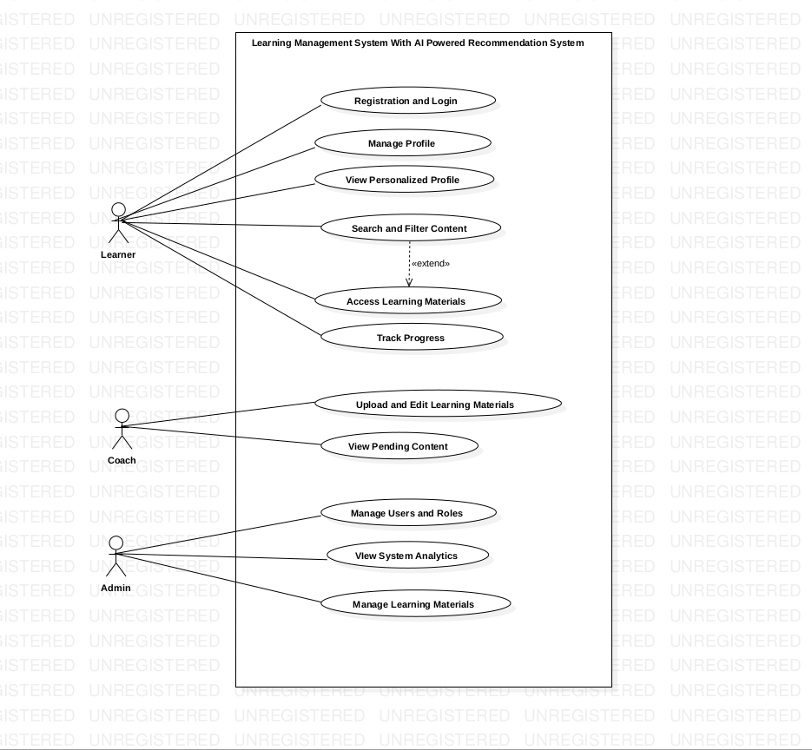

## 

## 

## **6. Use Case Descriptions**

**Use Case Number:** UC-01

**Use Case Name:** Registration and Login

**Overview:** Allows new users to create accounts and existing users to access the system securely

**Actors:** Learner, Coach, Admin

Pre-condition: User has access to the system URL

**Main Flow:**

1. User navigates to the system login page

2. User selects "Register" for new account or enters credentials for login

3. System validates user input

4. System creates account (for registration) or authenticates user (for login)

5. System redirects to appropriate dashboard based on user role

**Alternate Flows:**

2. Invalid credentials: System displays error message and returns to login

4. Registration validation fails: System highlights errors and asks for corrections

**Post Condition:** User is authenticated and logged into the system

**Use Case Number:** UC-02

**Use Case Name:** Manage Profile

**Overview:** Enables users to update their personal information and preferences

**Actors:** Learner, Coach, Admin

**Pre-condition:** User is logged in

**Main Flow:**

1. User navigates to profile settings

2. System displays current profile information

3. User modifies desired fields

4. System validates changes

5. System saves updated profile information

**Alternate Flows:**

4. Invalid input: System displays error and maintains current information

**Post Condition:** Profile information is updated in the system

**Use Case Number:** UC-03

**Use Case Name:** View Personalized Profile

**Overview:** Displays user-specific information and personalized recommendations

**Actors:** Learner

**Pre-condition:** User is logged in as a learner

**Main Flow:**

1. User accesses personalized profile view

2. System retrieves user's learning history and preferences

3. System generates personalized recommendations

4. System displays customized dashboard

**Alternate Flows:**

3. If no previous learning history or preferences is available:

* System displays a message informing the user that there is no learning history or preferences yet.
* System prompts the user to start exploring content or set preferences.

**Post Condition:** User views personalized profile and recommendations

**Use Case Number:** UC-04

**Use Case Name:** Search and Filter Content

**Overview:** Allows users to find specific learning materials using search criteria

**Actors:** Learner

**Pre-condition:** User is logged in as a learner

**Main Flow:**

1. User enters search terms or applies filters

2. System queries database for matching content

3. System displays filtered results

4. User can further refine search or select content

**Alternate Flows:**

3. No results found: System suggests alternative search terms

**Post Condition:** Relevant learning materials are displayed to user

**Use Case Number:** UC-05

**Use Case Name:** Access Learning Materials

**Overview:** Provides access to learning resources

**Actors:** Learner

**Pre-condition:** User is logged in as a learner

**Main Flow:**

1. User selects learning material

2. System checks access permissions

3. System delivers content to user

4. System records access timestamp

**Alternate Flows:**

3. Content unavailable: System displays appropriate message

**Post Condition:** User gains access to requested learning material

**Use Case Number:** UC-06

**Use Case Name:** Track Progress

**Overview:** Monitors and displays user's learning advancement

**Actors:** Learner

**Pre-condition:** User is logged in and has started learning activities

**Main Flow:**

1. User accesses progress tracking section

2. System retrieves completion data

3. System calculates progress metrics

4. System displays visual progress indicators

### **Alternate Flows**

2.If no learning activities are started, system prompts the user to begin an activity to track progress.

**Post Condition:** User views current learning progress

**Use Case Number:** UC-07

**Use Case Name:** Upload and Edit Learning Materials

**Overview:** Enables coaches to manage learning content

**Actors:** Coach

**Pre-condition:** User is logged in as a coach

**Main Flow:**

1. Coach selects upload/edit option

2. System displays content management interface

3. Coach uploads new content or modifies existing material

4. System validates content

5. System saves changes

**Alternate Flows:**

3. Upload fails: System provides error details

2. Invalid content: System requests corrections

**Post Condition:** Learning materials are updated in the system

**Use Case Number:** UC-08

**Use Case Name:** View Pending Content

**Overview:** Shows coaches content requiring completion

**Actors:** Coach

**Pre-condition:** User is logged in as a coach

**Main Flow:**

1. Coach accesses pending content section

2. System retrieves incomplete items

3. System displays pending content list

### **Alternate Flows**

1. If no pending content is found, system notifies the coach and suggests creating new content.

**Post Condition:** Coach views list of pending content items

**Use Case Number:** UC-09

**Use Case Name:** Manage Users and Roles

**Overview:** Allows administrators to control user access and permissions

**Actors:** Admin

Pre-condition: User is logged in as an admin

**Main Flow:**

1. Admin accesses user management section

2. System displays user list and role options

3. Admin modifies user roles or permissions

4. System updates user access rights

**Alternate Flows:**

3. Invalid role assignment: System prevents unauthorized changes

**Post Condition:** User roles and permissions are updated

**Use Case Number:** UC-10

**Use Case Name:** View System Analytics

Overview: Provides system-wide statistics and usage metrics

**Actors:** Admin

**Pre-condition:** User is logged in as an admin

**Main Flow:**

1. Admin accesses analytics dashboard

2. System retrieves usage statistics

3. System generates performance metrics

4. System displays analytical reports

### **Alternate Flows:**

1.

If permissions are insufficient, system denies access and prompts for the correct permissions.

**Post Condition:** Admin views system performance data

**Use Case Number:** UC-11

**Use Case Name:**Manage Learning Materials

**Overview:** Enables administrators to oversee all educational content

**Actors:**Admin

**Pre-condition:** User is logged in as an admin

**Main Flow:**

1. Admin accesses content management section

2. System displays all learning materials

3. Admin can modify, approve, or remove content

4. System updates content status

**Alternate Flows:**

1. Content in use: System warns before deletion

**Post Condition:** Learning materials are updated according to admin actions